TWO WAY TABLES
Pearson Edexcel - Tuesday 10 November 2009 - Paper 4 (Calculator) Higher Tier
1.
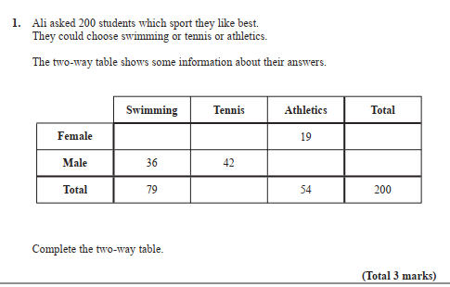
2.

